**OSC Status**

**Extranet Security:**

1. We are using SQL Server 2008 R2.
2. Error occurring while trying to Restore the backup file through SQL Query.

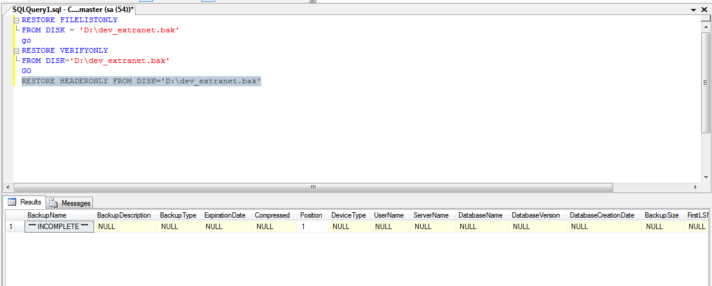

**ChefsChats :**

1. We downloaded the Backup File .
2. Same Error occurring while trying to restore the db.

